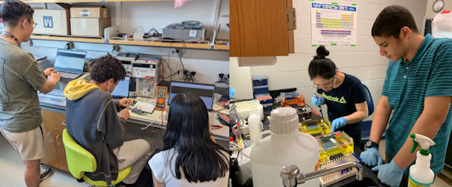  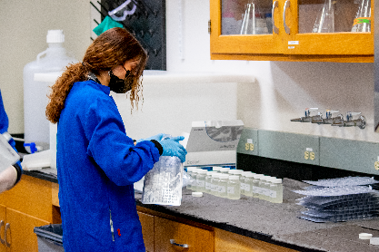  UPLIFT – FIRST YEAR  SEMINAR & RESEARCH  YOUR PATHWAY TO RESEARCH  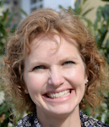  September 13th  "Musculoskeletal Mechanobiology"  • Professor Sandra Shefelbine [MIE/BioE]  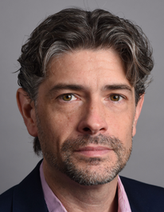  September 27th  "Operando Raman Spectroscopy of Battery Electrodes"  • Professor Joshua Gallaway [ChemE]  aa  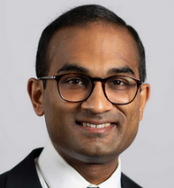  October 11th  "Microacoustic RF Signal Processing Devices"  • Professor Siddhartha Ghosh [ECE]  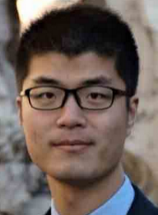  October 18th  "Soft Active Materials and Machines"  • Professor Ruobing Bai [MIE]  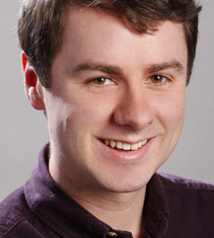  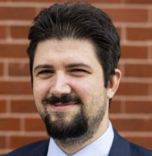  November 8th  "Shining light on Single Spins: Making Defects .in Diamond Useful"  • Professor Paul Stevenson [Physics]  December 4th (1-2pm in CSC 340)  “Adversarial and Embedded Machine Learning”  • Professor Francesco Restuccia [ECE] | Wednesdays 12-1  @ 103 Churchill  ---  Take your first step toward undergraduate engineering research  ---  Pre-Register Here:  ---  Seminar series attendees are invited to apply for a spring research placement
December 6th
“Applying for UPLIFT”

aa
UPLIFT:
Undergraduate Program for Leaders In Future Transformation
Web: uplift.sites.
northeastern.edu

